Logistic Regression
Logistic Regression is simple but powerful algorithm for linear and binary classification problems. Don’t get confused with name, Logistic Regression is a model for classification, not regression. Behind the Logistic Regression Model, there lies powerful Probability Concept.

Intuition
In the previous articles, we read how can we predict the continuous variables using Simple and Multiple Linear Regression. But when it comes about classification, not prediction – how do we solve it? Let’s say we want to find whether 1 party wins election or not, whether the person has disease or not, we need some sort of Classification Algorithm. Logistic Regression is one of the simplest yet powerful Machine Learning algorithm for classification.
Let’s see a data, we have Email Proposal and a data whether the user replied to that email or not. Some age group replied and some don’t. It can be either replied or not replied. Nothing in-between. So, you can rank 1 for +ve and 0 for negative. If we plot such data, we can see:
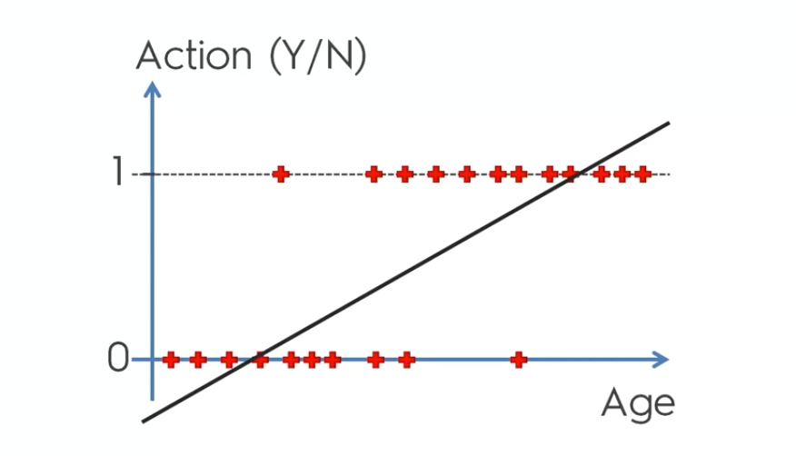

If a person replied it’s 1 and if not it’s 0. From the diagram, you can guess, aged people are more likely to reply to email. If we use of Linear Model, we can’t best fit the data.
Let’s think of it differently. How about Probability. We can say that the probability of Aged people replying to the mail is higher and data is in between 0 and 1.
From the same line we can guess, the probability is increasing with the age. The line in between 0 and 1 shows that the probability of replying to email increases on increasing the age. And the line above 1 and below 0. It says that the people whose age comes above are more than 100% likely to reply to mail and below are not likely to reply the mail.
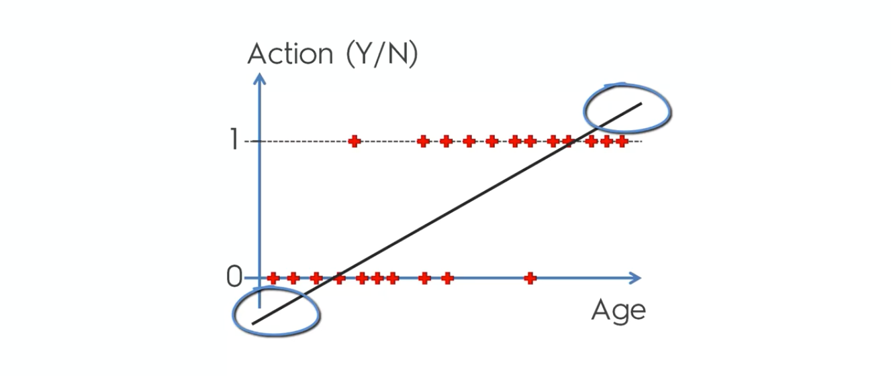
From this, we can create our NEW LOGISTIC REGRESSION MODEL like this:
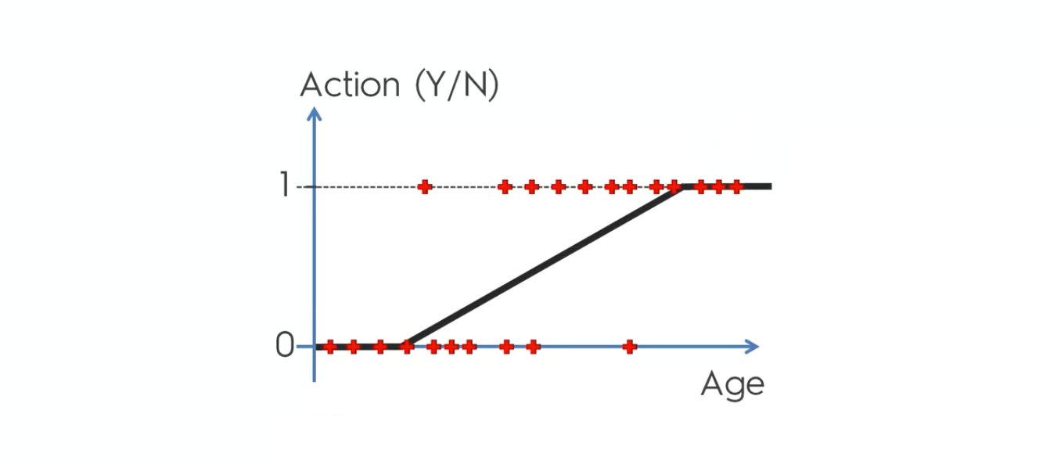

Okay, but what’s going on there. Show me maths??
First take our Simple Linear Regression Model and apply a Sigmoid function to it. Then, you will get our Logistic Regression Model.
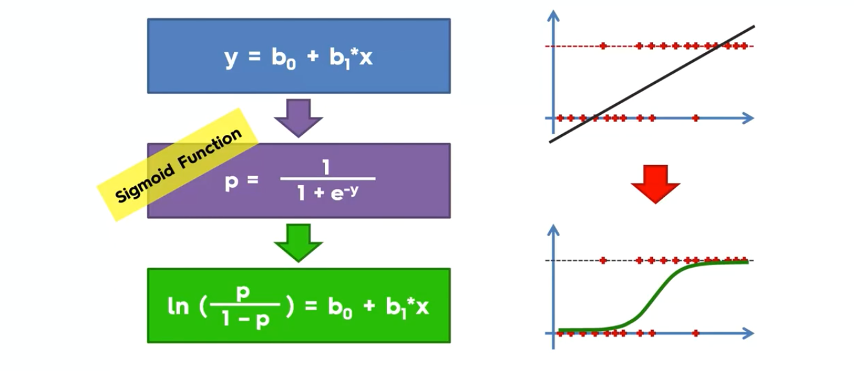

It’s simple, you just put value of y in sigmoid function and criss-cross at “=”.
Here, P is the probability of getting a positive result and always ranges from 0 to 1. The ln is natural log.
Using that function, we got our best fitting line. Now, forget the dataset and let’s predict whether user replies mail or not.
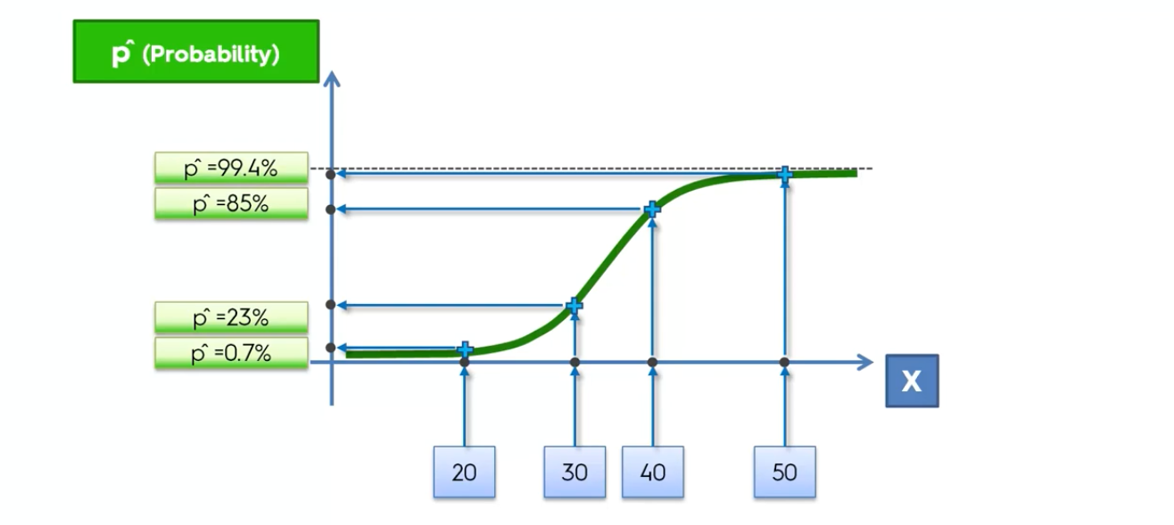

From the figure, we can say, people aging 40 and 50 have maximum probability to reply the mail and 20,30 least. You can say if p=>50% it’s 1 else 0.
In this we can can make a prediction whether people with certain age reply the email or not. We can use same concept for different Binary Classification problems like is user having cancer or not, whether our customer buy or not and so on.
You can also extend model to multi-class classification via OvR technique.

How we train the Model?
Unfortunately we can’t use the same cost function MSE or R2 as we did for linear regression. Why? Because Logistic Regression is non-linear and if we apply gradient descent in non-convex data, we will get many local minimums and can’t find global minimum.
We use a cost function called Cross Entropy. Cross-entropy loss can be divided into two separate cost functions: one for y=1 and one for y=0.
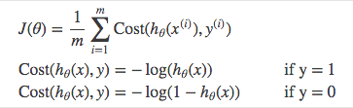

In case of training the model, we have output either 1 or 0. If output is 1 we will use 1st equation of above and find the best weight. We update the weight using gradient descent. Similarly, if output is 0 we use 2nd equation to measure the cost function. The model finds the lowest cost function. For updating the weights we can use Gradient Descent Approach.
Let’s code. It’s quite similar to previous blogs. So, I don’t think it needs any explanation.
Importing the Dataset.

